**GENERAL HUMAN BIOLOGY – YEAR 11**

**TASK 10 – Pregnancy & Birth Test**

**WEIGHTING: 10%**

**NAME: ______________________ TOTAL = ______/54**

**Section One: Multiple Choice 14 marks**

1. Which of the following forms of contraception protect against STIs
   1. Cup/Diaphragm
   2. Condom
   3. Combined pill
   4. IUD
2. Where does fertilisation occur
   1. Uterus
   2. Ovary
   3. vagina
   4. Fallopian tube
3. During IVF-ET to increase the chances of success when does implantation occur?
   1. Blastocyst
   2. 8 cell stage
   3. 4 cell stage
   4. Zygote
4. During which month does a foetus develop the ability to respond to sound?
   1. 2
   2. 4
   3. 6
   4. 8
5. What is it called when the placenta blocks the birth canal?
   1. Placental abruption
   2. Placenta expulsion
   3. Placenta nuchal
   4. Placental previa
6. When would a potential parent use FET?
   1. To improve the success rate of IVF
   2. During GIFT
   3. Death of a spouse
   4. Breast cancer
7. Which is the correct definition of a teratogen?
   1. An environmental agent that affects the unborn child and produces a birth defect
   2. An environmental agent that affects the mother and causes infertility
   3. An environmental agent that affects the mother’s health only
   4. An environmental agent that affects the father’s health only
8. During which month can a heartbeat be detected?
   1. 1
   2. 3
   3. 5
   4. 7
9. What hormone is produced by the mother and placenta to maintain pregnancy?
   1. Oestrogen
   2. Progesterone
   3. Testosterone
   4. LH
10. An ultrasound is….
    1. A scan that uses high frequency sound waves to detect movement
    2. A scan that uses high frequency sound waves to detect a heartbeat
    3. A scan that uses high frequency sound waves to create an image of the cervix
    4. A scan that uses high frequency sound waves to create an image of internal organs
11. During the third stage of labour what is a major risk?
    1. Miscarriage
    2. SIDS
    3. Blood loss
    4. Unconsciousness
12. Which is an effect of smoking on male fertility?
    1. Menopause onset
    2. Lower sperm count
    3. Increase risk of prostate cancer
    4. Decrease in viable sperm
13. Which is the correct sequence of development
    1. Zygote, embryo, blastocyst and foetus
    2. Blastocyst, zygote, embryo and foetus
    3. Blastocyst, embryo, zygote, foetus
    4. Zygote, blastocyst, embryo and foetus
14. In which month can sex be determined through ultrasounds
    1. 2
    2. 4
    3. 6
    4. 8

**Section Two: Short Answer 40 Marks**

1. Ultrasounds are important during late pregnancy and during labour. What is being monitored during this stage? (3 marks)

1. If a woman goes beyond her due date, explain 1 risk to the health of the baby? (2 marks)

1. If a baby is born premature before 37 weeks what is the main concern? (2 marks)

1. Name one genetic disorder that can be diagnosed before birth (1 mark)

1. During the birthing process many things could go wrong including an umbilical cord prolapse. Explain why this could occur? (5 marks)

1. The umbilical cord is an umbrella term that includes an artery and vein, explain the role these have during pregnancy (4 marks)

1. If a baby is breech, explain what this means and what affect his has on delivery. (2 marks)

1. If a woman is using heroin during pregnancy, explain how this affects the unborn child and infant. (5 marks)

1. Using the diagrams below label which type of assistive reproductive technology is being used (2 marks)

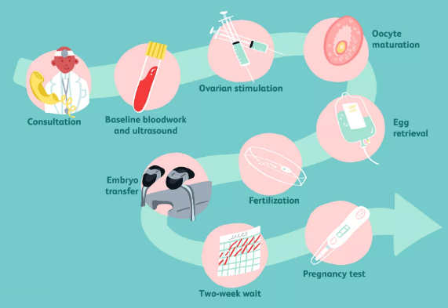 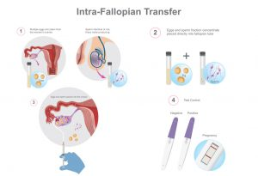

* 1. b.

1. Explain the differences between the mini pill and combined pill. (6 marks)

1. Some people believe in the natural family planning method of contraception, explain why this is only 70% effective compared to other methods (3 marks)

1. Explain why early diagnosis is important if an ectopic pregnancy occurs (3 marks)

1. state 2 risk factors that increase the chances of an ectopic pregnancy (2 marks)

**End of Questions**